Course Specialist Year 12 Test Two 2022

Student name: ________________ Teacher name: ________________

Task type: Response

Time allowed for this task: _____40______ mins

Number of questions: _____6______

Materials required: Upto 3 Calculators with CAS capability (to be provided by the student)

Standard items: Pens (blue/black preferred), pencils (including coloured), sharpener, correction fluid/tape, eraser, ruler, highlighters

Special items: Drawing instruments, templates, notes on one unfolded sheet of
A4 paper, and up to three calculators approved for use in the WACE examinations

Marks available: __41____ marks

Task weighting: _10___%

Formula sheet provided: Yes

Note: All part questions worth more than 2 marks require working to obtain full marks.

Q1 (2, 3 & 3= 8 marks)
Consider the functions and
- Determine the natural domains of .

- Does exist over the natural domain of ? Explain.

- State the rule and largest possible domain for and its corresponding range.

Q2 (2, 4, 1 & 3 = 10 marks)
The function is defined below for .
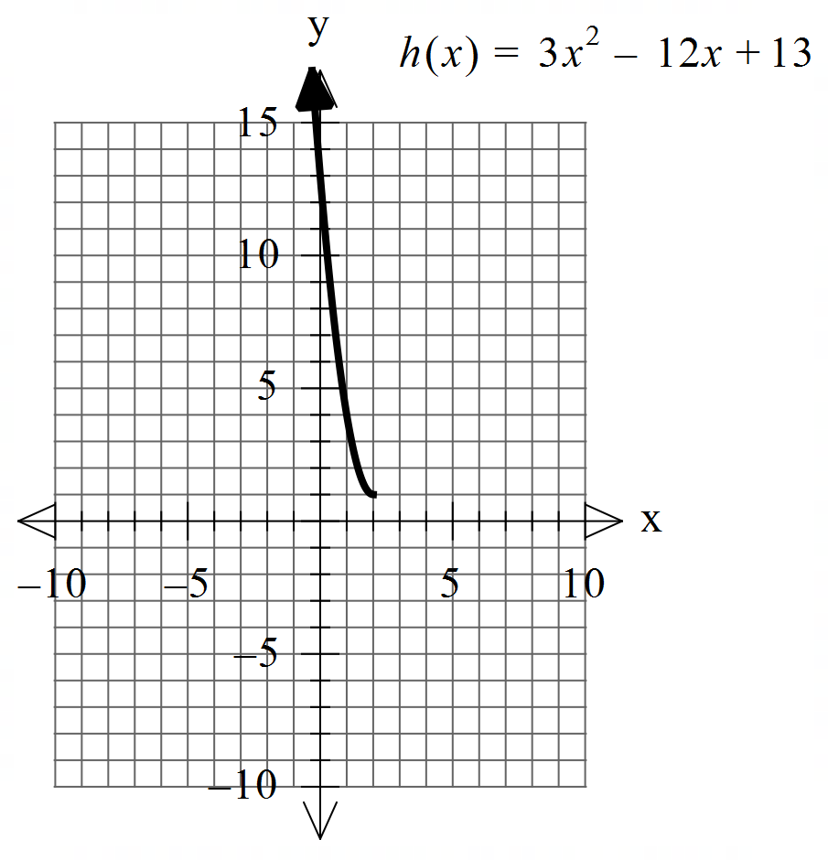

- Sketch the inverse function on the axes above.

Q2 continued
- Determine the rule for and its domain showing full working.

- Determine .

- Determine the exact coordinates (if any) for where .

Q3 (2 & 3 = 5 marks)
Consider the function which is plotted below.

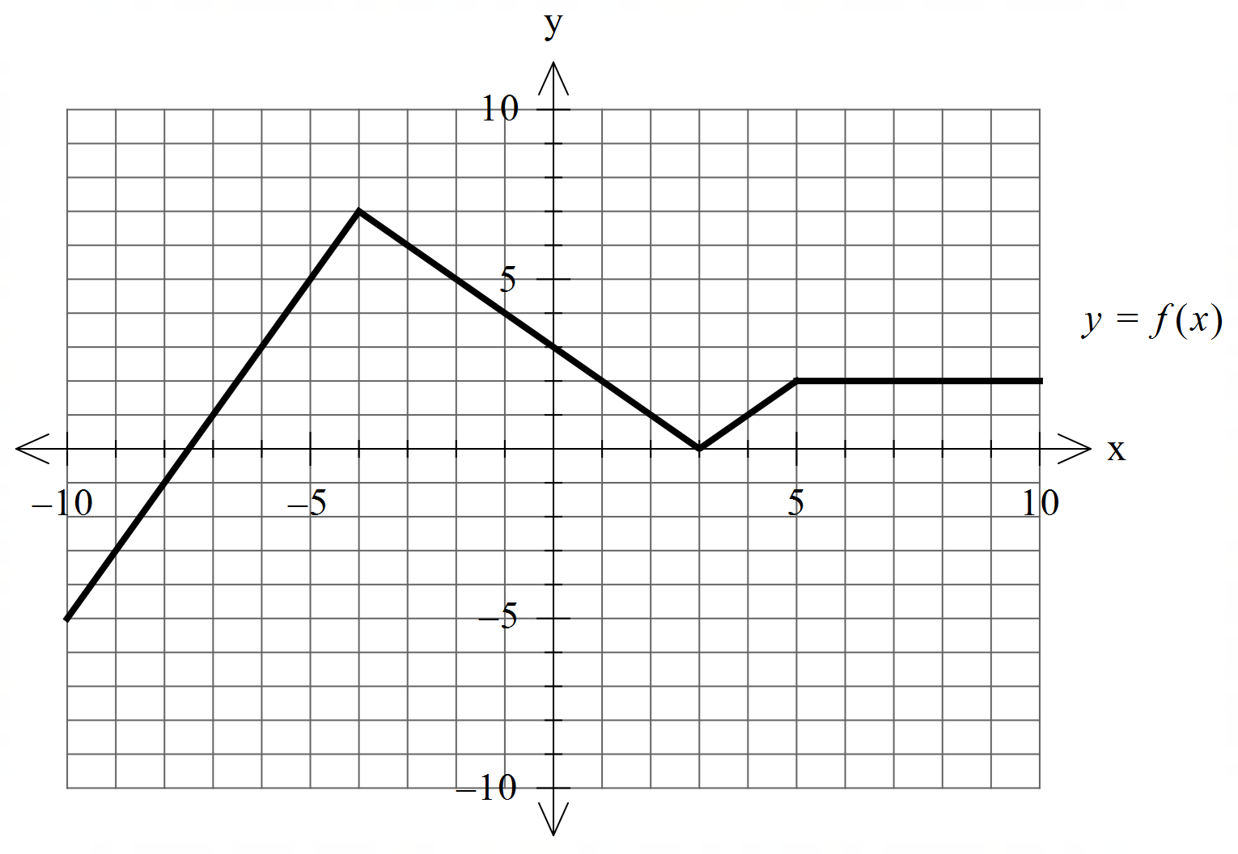

- Sketch

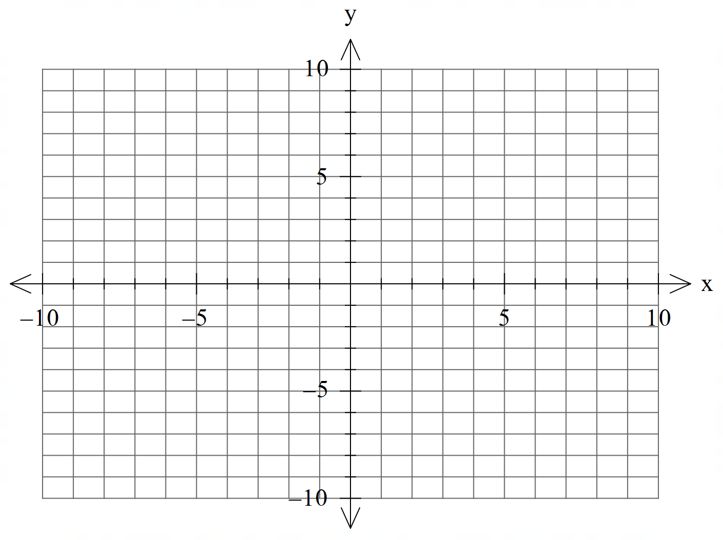

b) Sketch

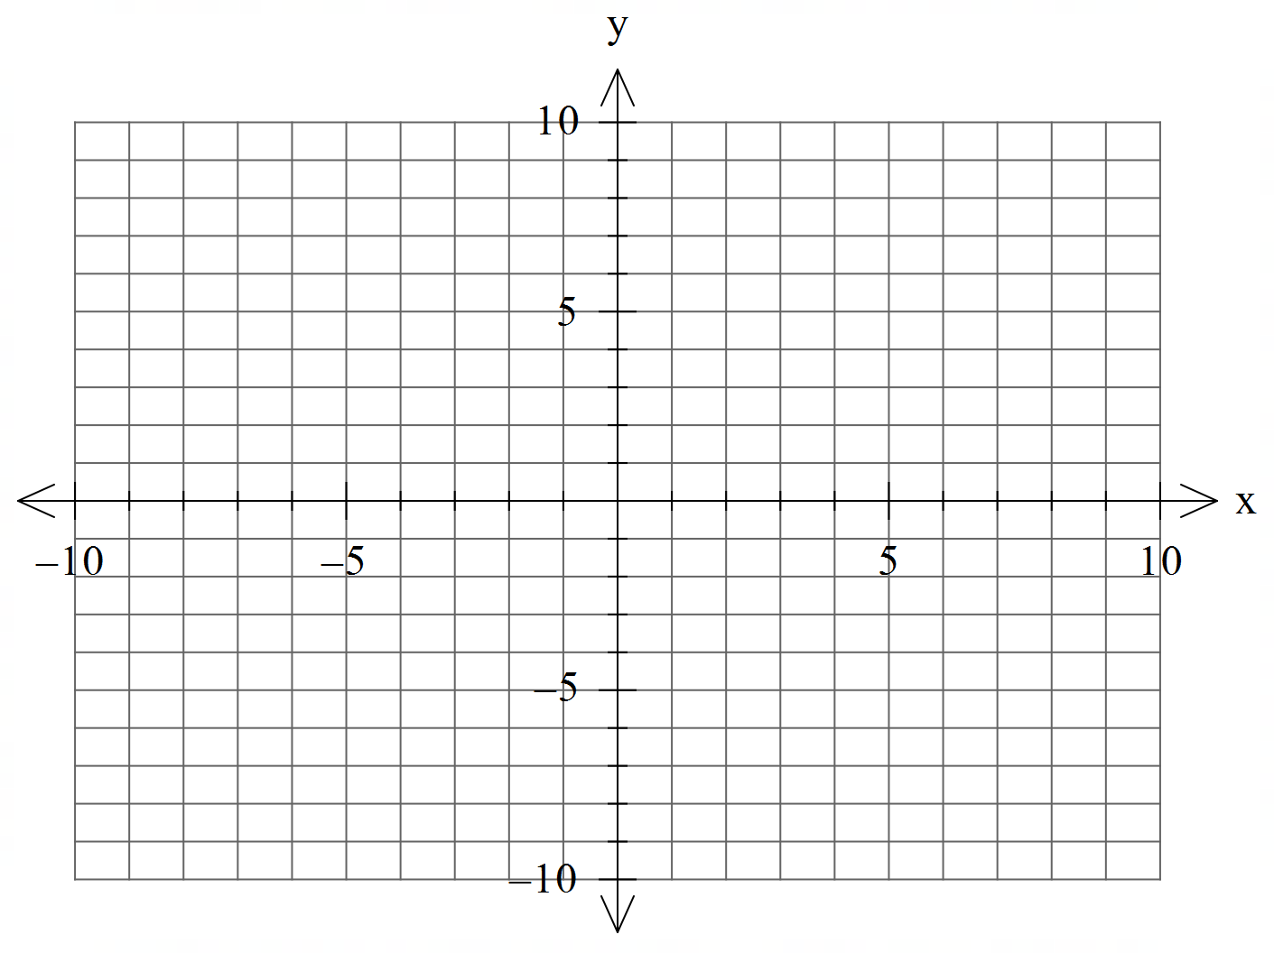

Q4 (4 marks)
Consider two moving objects A & B such that at seconds metres and metres per second. Determine the closet approach using vector methods.

Q5 (6 marks)
Consider a sphere with a constant and the line .
Determine all possible real values of such that:
- the line meets the sphere at two pints.
- the line is a tangent to the sphere.
- the line misses the sphere completely.

Q6 (2, 3 & 3 = 8 marks)
Consider the plane given by .

- The point is on a plane parallel to . Determine the cartesian equation of this plane.

- Determine the distance between these two planes. Show full reasoning.

- Consider the lines and . Determine the distance between these lines.

Extra working space

